**AIM: To develop use case diagram and class diagram for the given problem statement.**

**Theory:**

UML:

1. UML, short for Unified Modeling Language, is a standardized modeling language consisting of an integrated set of diagrams, developed to help system and software developers for specifying, visualizing, constructing, and documenting the artifacts of software systems, as well as for business modeling and other non-software systems. The UML represents a collection of best engineering practices that have proven successful in the modeling of large and complex systems.
2. The UML is a very important part of developing object oriented software and the software development process. The UML uses mostly graphical notations to express the design of software projects. Using the UML helps project teams communicate, explore potential designs, and validate the architectural design of the software.

Purpose of UML:

1. To reason about system behavior.
2. To detect errors and omissions early in the life cycle.
3. To present proposed designs and communicate with stakeholders.
4. To understand requirements.
5. To drive implementation.

Use Case Diagram:

Use case diagrams are used to gather the requirements of a system including internal and external influences. These requirements are mostly design requirements. Hence, when a system is analyzed to gather its functionalities, use cases are prepared and actors are identified.

In brief, the purposes of use case diagrams can be said to be as follows −

1. Used to gather the requirements of a system.
2. Used to get an outside view of a system.
3. Identify the external and internal factors influencing the system.
4. Show the interaction among the requirements are actors.

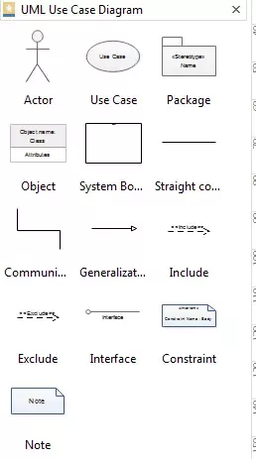

Class Diagram:

1. Class diagram is a static diagram. It represents the static view of an application. Class diagram is not only used for visualizing, describing, and documenting different aspects of a system but also for constructing executable code of the software application.
2. Class diagram describes the attributes and operations of a class and also the constraints imposed on the system. The class diagrams are widely used in the modeling of object oriented systems because they are the only UML diagrams, which can be mapped directly with object-oriented languages.

Purpose of Class Diagram:

The purpose of the class diagram can be summarized as −

1. Analysis and design of the static view of an application.
2. Describe responsibilities of a system.
3. Base for component and deployment diagrams.
4. Forward and reverse engineering.

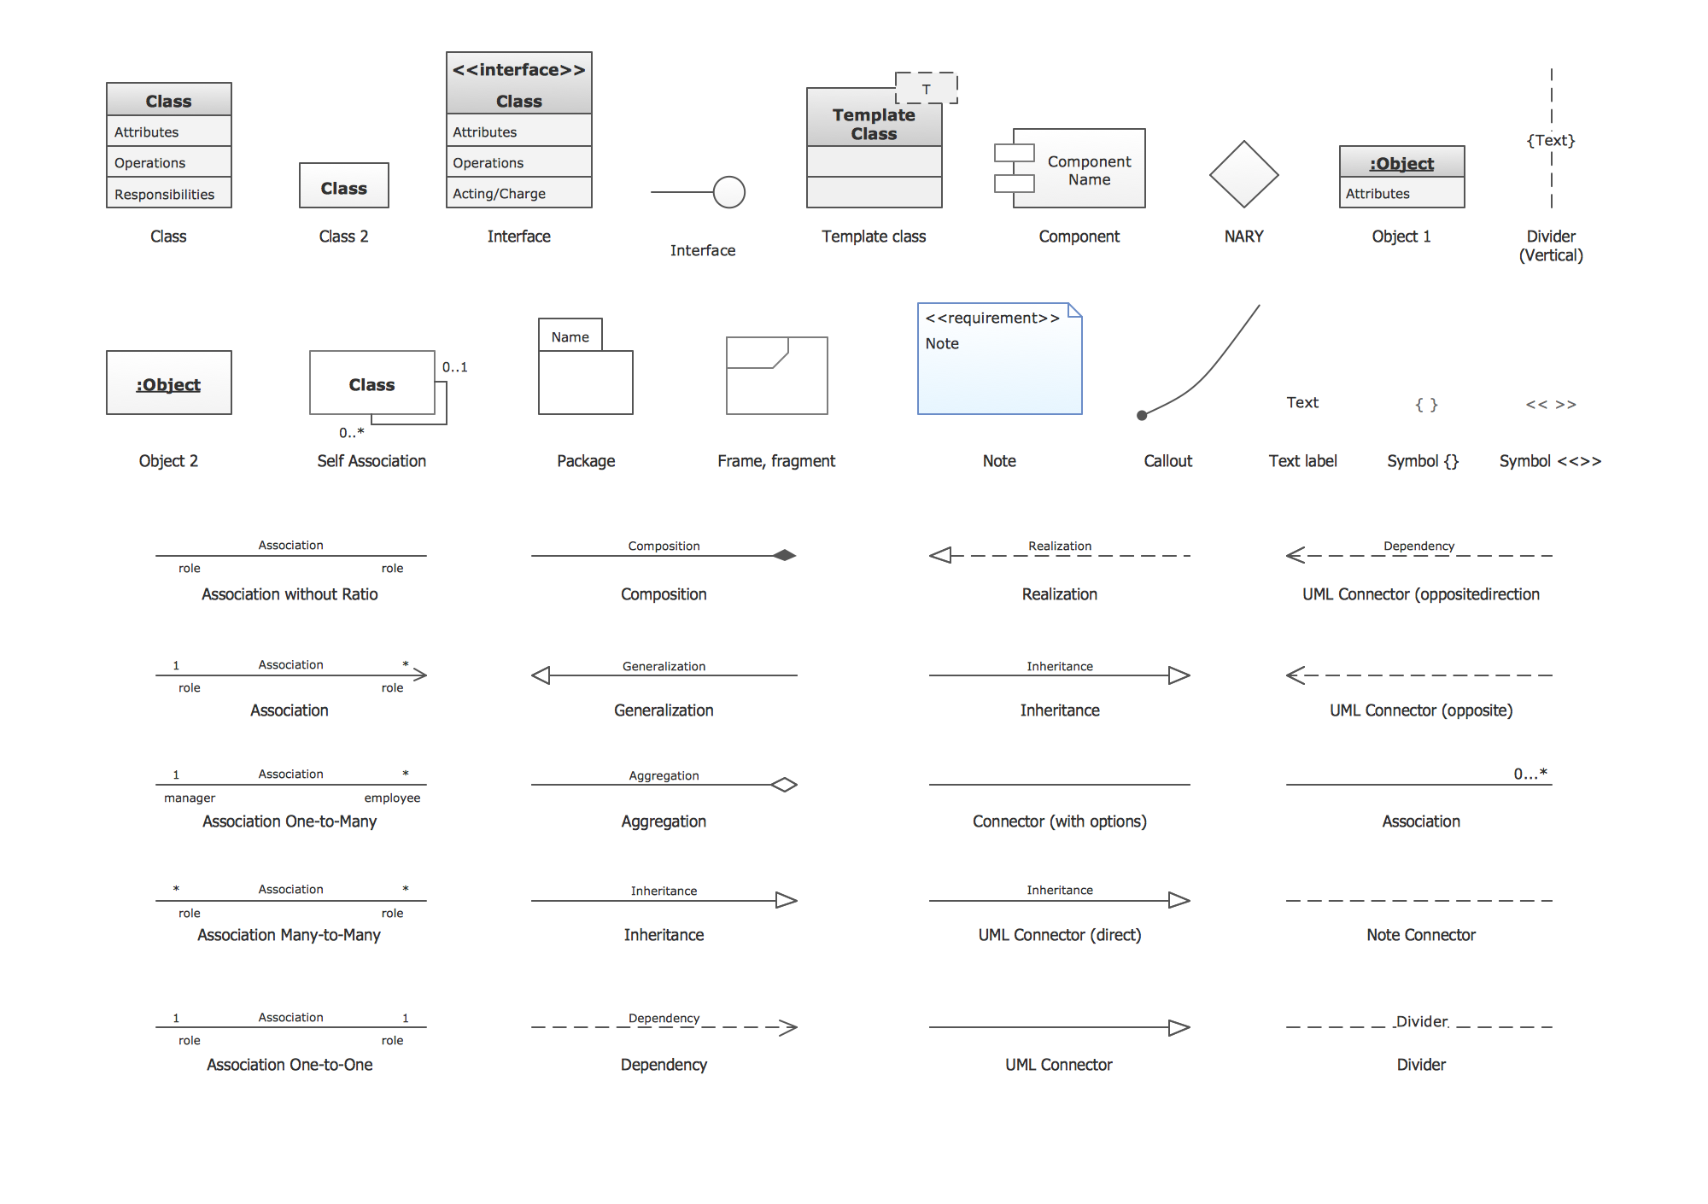

Class Diagram of our Problem Statement:

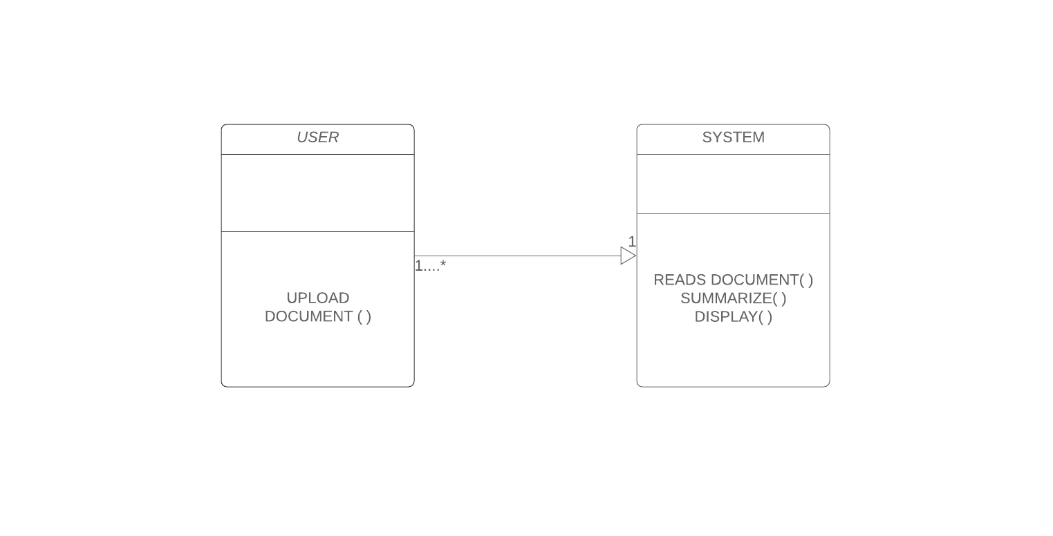

User:

Methods:

1. upload_document()

System:

Methods:

1. read_document()
2. summarize()
3. display()

Use Case Diagram of our Problem Statement:

